**Proposal for Implementing Secure Online Shopping System**

Contents

Introduction 2

Background 2

Objectives 2

Benefits of Implementing an OSS 2

Potential Cyber Threats 3

UML Diagrams 3

Threat Modelling Techniques 5

Security Measures 6

Implementation Plan 6

Conclusion 7

References 8

## Introduction

As the head of our cyber security-focused IT consulting firm, I am pleased to propose this proposal aimed at meeting the requirements of a local grocery shop seeking to enhance its operations by implementing an online shopping system (OSS). This proposal presents the advantages of the Open-Source Software (OSS), possible cyber risks, and suggested security measures utilising UML diagrams and threat modelling approaches.

## Background

The local grocery business caters to an expanding population and intends to introduce an online shopping system to improve customer service and operational efficiency. Nevertheless, the shop owner is apprehensive about the escalating cybercrime rates and the government's stringent data protection policies. This concept seeks to address these concerns by establishing a secure open-source software (OSS) system.

Given the increasing prevalence of cybercrime, specifically aimed at small and medium-sized firms (SMEs), it is imperative for businesses to have strong security protocols. Although the implementation of an open-source software (OSS) brings about many advantages, it also presents certain security obstacles that want thorough resolution. Enterprises are currently experiencing a process of digitali**s**ation, highlighting the importance of protecting consumer data and strengthening the system against cyber risks.

## Objectives

The primary objectives of this proposal are to:

* Open-Source Software (OSS) for the neighbourhood grocery store.
* Determine any cybersecurity risks linked to the OSS.
* Suggest security protocols to minimise these risks.
* Utilise UML diagrams to offer a concise and visually explicit depiction of the system.
* Utilise threat modelling approaches to provide thorough security coverage.

## Benefits of Implementing an OSS

Implementing an open-source software (OSS) can offer numerous benefits for the grocery business, such as:

**Improved Customer Experience:** Customers have the convenience of shopping online, exploring product options, placing orders, and scheduling delivery or pickup, resulting in heightened customer satisfaction and loyalty.

operating efficiency refers to the ability of an OSS to optimise and simplify several company processes, including inventory management, sales tracking, and customer support. This results in enhanced efficiency and decreases operating expenses.

**Market Expansion:** By establishing an online presence, the grocery shop can access a wider client base, including those who prefer online purchasing, so expanding its market reach.

**Data Analytics:** The Open-Source Software may offer significant knowledge about consumer behaviour, sales patterns, and inventory control by utilising data analytics. This, in turn, assists the shop owner in making well-informed business choices.

By using a secure open-source software, organisations can assure compliance with data protection rules, thereby avoiding legal consequences and fostering consumer trust.

In addition, the OSS can provide promotional opportunities, enabling the shop to focus on particular client categories by offering customised promotions and discounts. Implementing this degree of customisation can significantly improve client interaction and stimulate sales expansion. Implementing advanced analytics can enhance inventory optimisation by maintaining consistent availability of popular commodities and minimising the holding costs of less popular products.

## Potential Cyber Threats

The implementation of an OS**S** also introduces potential cyber vulnerabilities that must be mitigated in order to safeguard the organisation and its clientele. Several prevalent hazards include:

Data breaches occur when there is unauthorised access to sensitive consumer information, including personal details and payment information. These breaches can cause financial losses and damage to a company's brand.

Phishing attacks, a method employed by cybercriminals, involve the use of deceptive strategies to trick customers into revealing their sensitive information. This poses a substantial risk to client security.

Malware attacks, such as viruses, ransomware, and spyware, have the potential to corrupt the OSS, interrupt normal operations, and illicitly acquire sensitive data.

Denial of Service (DoS) assaults can inundate the OSS with an excessive amount of traffic, resulting in its failure and unavailability to clients. This can result in a decline in sales and erosion of customer trust.

SQL Injection **a**ttackers can exploit weaknesses in the OSS to carry out harmful SQL queries, enabling them to gain unauthorised access to and manipulate the database.

Furthermore, cyber risks are ever advancing, as attackers devise novel techniques to circumvent security systems. It is imperative to remain informed about the most recent threat intelligence and adjust security procedures accordingly. Insider threats, referring to personnel who have authorised access to the system and intentionally or accidentally do harm, also present a substantial risk. Consistent training and awareness programmes are necessary to reduce these dangers.

## UML Diagrams

To illustrate the system's structure and data flow, we have used UML diagrams. These diagrams provide a clear visual representation of the system's components and interactions, aiding in identifying and mitigating potential security threats.

#### Abuse Case Diagram

The Abuse Case Diagram highlights potential misuse of the system by cyber-criminals and malicious staff. This diagram is crucial for identifying security threats and developing countermeasures.

#### Sequence Diagram

The Sequence Diagram captures the interaction sequence between actors and the system. This helps in understanding the dynamic behaviour and potential vulnerabilities in the data flow.

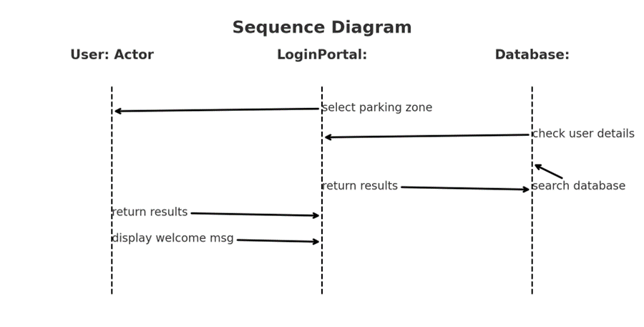

#### Class Diagram

The Class Diagram represents the static structure of the system, depicting classes, attributes, methods, and their relationships. This diagram is essential for understanding the system's design and identifying potential security weaknesses.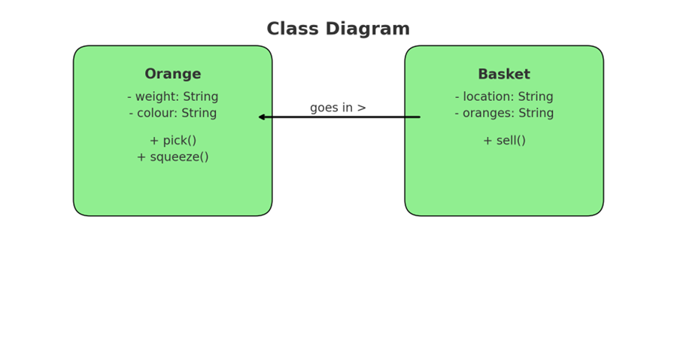

## Threat Modelling Techniques

We have utilised two main threat modelling techniques to identify and address potential cyber threats to the OSS:

#### STRIDE

The STRIDE model helps identify security threats in six categories: Spoofing, Tampering, Repudiation, Information Disclosure, Denial of Service, and Elevation of Privilege (Howard & LeBlanc, 2003). By analysing these categories, we can proactively address potential security issues.

Spoofing: Attackers may try to impersonate legitimate users in order to obtain unauthorised entry into the system.

Tampering: Cybercriminals have the ability to modify data within the system, which can result in problems with the accuracy and reliability of the data.

Repudiation: Users may deny having performed certain actions, leading to challenges in accountability.

Information Disclosure: Sensitive information may be exposed to unauthorised users.

Denial of Service (DoS): Attackers may disrupt the system’s availability, preventing legitimate users from accessing the service.

Elevation of Privilege: Attackers may gain elevated access rights, enabling them to perform actions beyond their authorisation.

#### DREAD

The DREAD model evaluates the potential impact of security threats based on Damage potential, Reproducibility, Exploitability, Affected users, and Discoverability (Shostack, 2014). This technique prioritises threats based on their potential impact, enabling us to allocate resources effectively.

* Damage Potential: Assesses the extent of damage a threat can cause if it materialises.
* Reproducibility: Evaluates how easily the threat can be reproduced by an attacker.
* Exploitability: Measures the effort required to exploit the threat.
* Affected Users: Estimates the number of users impacted by the threat.
* Discoverability: Assesses how easily the threat can be discovered by an ​​attacker.

By using the STRIDE and DREAD models, we can comprehensively identify and prioritise potential threats, ensuring that the most critical issues are addressed first.

## Security Measures

To mitigate the identified cyber threats, the following security measures are recommended:

* **Encryption**: Implement robust encryption techniques to protect sensitive data both in transit and at rest. This ensures that even if data is intercepted, it remains unreadable to unauthorised parties.
* **Authentication and Authorisation**: Use strong authentication mechanisms such as multi-factor authentication (MFA) to verify user identities. Implement role-based access control (RBAC) to ensure users have access only to the resources they need.
* **Regular Security Audits**: Conduct regular security audits and vulnerability assessments to identify and address potential security weaknesses in the OSS.
* **Employee Training**: Train employees on security best practices and how to recognise and respond to potential cyber threats such as phishing attacks.
* **Incident Response Plan**: Develop and implement an incident response plan to quickly and effectively respond to security incidents, minimising their impact.
* **Software Updates**: Regularly update the OSS and all related software to patch known vulnerabilities and improve security.

## Implementation Plan

The implementation of the OSS will follow a structured plan to ensure its security and operational efficiency. The plan includes the following steps:

* **Requirements Analysis**: Conduct a thorough analysis of the business requirements and security needs of the grocery shop.
* **System Design**: Develop a detailed system design using UML diagrams to illustrate the structure and interactions within the OSS.
* **Development**: Implement the OSS using secure coding practices, ensuring that all identified security measures are incorporated.
* **Testing**: Perform rigorous testing, including security testing, to identify and address any vulnerabilities before deployment.
* **Deployment**: Deploy the OSS in a secure environment, ensuring all security measures are in place.
* **Monitoring and Maintenance**: Continuously monitor the OSS for potential security threats and perform regular maintenance to keep the system secure and up to date.

## Conclusion

This proposal presents a comprehensive plan to establish a robust and protected e-commerce platform for the nearby grocery store. Through the utilisation of UML diagrams and threat modelling approaches, we can guarantee the security and operational efficiency of the system. The proposed approach will not only improve client pleasure but also safeguard the shop against any **cyber-attacks**. Implementing stringent security protocols will ensure a secure shopping experience for clients, adhere to data protection standards, and fortify the firm against cyber threats.

By adhering to the suggested security protocols and adhering to the well-organi**s**ed implementation strategy, the grocery store may confidently shift to an online platform, ensuring a safe and streamlined shopping experience for its customers. Implementing this proactive strategy will not only reduce the impact of possible cyber-attacks, but also enhance consumer trust and loyalty, ultimately leading to the long-term success of the firm.

## References

* Anderson, R. (2008). Security Engineering: A Guide to Building Dependable Distributed Systems. 3rd ed. Indiana: Wiley & Sons.
* Howard, M. & LeBlanc, D. (2003). Writing Secure Code. 2nd ed. Microsoft Press.
* McGraw, G. (2006). Software Security: Building Security In. Boston: Addison-Wesley Professional.
* Shostack, A. (2014). Threat Modeling: Designing for Security. Indianapolis: Wiley.
* Connolly, T. & Begg, C. (2005). Database Systems: A Practical Approach to Design, Implementation, and Management. 5th ed. Pearson/Addison Wesley.
* Severance, C. (2016). Python for Everybody: Exploring Data Using Python 3. 1st ed. CreateSpace Independent Publishing Platform.
* Gupta, S. B. & Aditya, M. (2017). Introduction to Database Management System. University Science Press.
* Gries, P., Campbell, J. & Montojo, J. (2017). Practical Programming: An Introduction to Computer Science Using Python 3.6. 3rd ed. Raleigh: The Pragmatic Bookshelf.
* Hetland, M. L. (2017). Beginning Python: From Novice to Professional. 3rd ed. Apress Media.
* Phillips, D. (2018). Python 3 Object-Oriented Programming: Build Robust and Maintainable Software with Object-Oriented Design Patterns in Python 3.8. Packt Publishing Ltd.
* Ambler, S. W. (2003). The Elements of UML Style. Cambridge University Press.
* Booch, G., Rumbaugh, J. & Jacobson, I. (2005). The Unified Modeling Language Reference Manual. 2nd ed. Addison-Wesley.
* Kong, J., Xu, D. & Zeng, X. (2010). UML-Based Modeling and Analysis of Security Threats. International Journal of Software Engineering and Knowledge Engineering, 20(6), 875-897.
* Seidl, M., Scholz, M., Huemer, C. & Kappel, G. (2015). UML @ Classroom: An Introduction to Object-Oriented Modeling. Springer International Publishing.
* Van Rossum, G., Warsaw, B. & Coghlan, N. (2013). Python Developer's Guide. Python Software Foundation.
* Dionysis, Z. (n.d). A Gentle Introduction to Algorithm Complexity Analysis.
* Visual Paradigm Online. (n.d.). Retrieved from <https://online.visual-paradigm.com/drive/#diagramlist:proj=0&dashboard>